
LARGE UNIT NAME
Subunit Name, Building, Room Number
4400 University Drive, MS Number, Fairfax, Virginia 22030
Phone: 703-000-0000; Email: name@gmu.edu; Web: website.gmu.edu

[Date letter is created]

[Candidate First Name] [Candidate Last Name]
[Street Address]
[City], [State] [Zip]

Dear [Candidate First Name] [Candidate Last Name]:

It is my pleasure to offer you the position of adjunct faculty. I believe you will find George Mason University an exciting and rewarding environment in which to work, and a place where the contributions of faculty are valued.

This offer is subject to the terms and conditions of the “Adjunct Faculty Terms and Conditions of Employment”, attached hereto as “Attachment A”, which is incorporated herein by reference.

The terms of this offer are as follows:

- Term: [FOR FALL SEMESTER:
August 25, 20__ through December 9, 20__.
FOR SPRING SEMESTER:
January 25, 20__ through May 9, 20__.

- Appointment: Adjunct Faculty appointment.

- Salary: [Proposed Annual Salary]. Payroll dates may not correspond to dates of the Term.

- FTE: [.xx]

- Assignment: You are assigned to [LOCAL ACADEMIC UNIT] and will report to [_____________].

- Course / Section: xxxx
Date and Time details for this course is located on Patriot Web.

- CRN: xxxx

- Other Terms: An original transcript from the institution awarding the highest degree should be mailed to the [responsible party in dean’s office. Please mail to: Mailing address to receive transcript].

The University reserves the right to reschedule or reassign the teaching responsibilities for this appointment, or to cancel this appointment.

If you are a new employee, before your first day of employment, please visit the New Employee Welcome (NEW) Center website (https://hr.gmu.edu/new-employees) for complete in-processing instructions.

By signing this appointment letter, you agree not to teach more than ten (10) credit hours within a semester at George Mason University, including those referred to in this contract. You also agree that you do not have any additional duties at George Mason University, administrative or otherwise, which combined with your teaching load would be equivalent to a workload of more than 10 credit hours within a semester. You also understand that the dates of the term may not correspond to actual pay dates.

If these terms and conditions are acceptable to you, please sign and date in the space provided below, initial at the bottom right of each page, and return the original to my office. This offer will remain open until xxxx; if you do not sign and return this offer of employment before such date, this offer will be null and void.

I look forward to your acceptance of this offer and to a rewarding professional association in the future. Should you need additional information or assistance, please do not hesitate to call me. My telephone number is xxxx.

Sincerely,

Xxxx - Only to be signed by the authorized delegate noted in the memo of Signature Delegation specific to each unit. Please contact your unit HR representative.

I accept the appointment described under the terms and conditions set forth in this letter, including all terms and conditions in the Attachment referenced in this letter. I further acknowledge that I will be governed by the administrative policies and regulations of the University, currently in force and as amended in the future. I also acknowledge that said rules do not create any vested employment rights and that the University reserves the right to reassign me during my term of employment.

_____________________________________________ _______________________
[Candidate First Name] [Candidate Last Name] Date

cc: xxxx

ATTACHMENT A

Adjunct Faculty Terms and Conditions of Employment

- Eligibility for Employment. Your employment is contingent upon providing the University, prior to your first day of employment, official documentation of degrees earned. An original transcript from the institution awarding the highest degree mailed to the hiring department will ordinarily satisfy this requirement. Please forward to the responsible party noted in other terms of this contract. You are responsible for providing a certified third-party translation and evaluation of your academic transcripts, if required by the University. Your employment is contingent upon satisfying all federal employment eligibility requirements, including any necessary work authorizations, and is contingent upon compliance with all applicable federal rules and regulations, including but not limited those federal rules and regulations regarding sponsored research. Your employment is contingent upon making no false or misleading representations in your application for employment. Your employment is contingent upon a successful background investigation; if the results of such investigation are not satisfactory to the University, this contract is voidable by the University. Questions regarding employment-based immigration should be directed to the Office of International Programs and Services.

- Approval of Appointment. This appointment is subject to approval by the appropriate University administrative officers. This appointment is also subject to the policies and bylaws of the Board of Visitors.

- Termination. Notwithstanding anything herein to the contrary, this is an at-will appointment and may be terminated at any time by the University without cause, by providing written notice to you.

- General Conditions of Employment. George Mason University is an agency of the Commonwealth of Virginia, organized pursuant to statute. As is the case for all University employees, your employment is subject to the Acts of the General Assembly of Virginia, Executive Orders of the Governor, regulations adopted by the Board of Visitors of the University, all applicable regulations, and all policies of the University. As a condition of your employment, you are subject to all applicable practices, policies and procedures of the University, including but not limited to policies regarding conflicts of interests, nondiscrimination, outside professional activities, and intellectual property. It is your responsibility to be aware of these policies and procedures, as well as all others which may apply to you. University policies and procedures are subject to change without notice. You agree to make best efforts to successfully perform your duties under this contract.

- Benefits. You may be eligible to receive certain benefits provided to Commonwealth of Virginia and University employees. You are responsible for making all decisions and for taking all actions relating to such benefits, within established timeframes and deadlines. Questions regarding benefits should be directed to the Department of Human Resources and Payroll.

- Taxation and Direct Deposit. All amounts paid by the University to you may be subject to taxation both for reporting and withholding. Any amounts subject to withholding will have taxes withheld in accordance with federal and state law. If you accept this offer and it is your first appointment to George Mason University, you must complete tax forms in order to receive payment. Electronic direct deposit is mandatory for all employees.

- Assignment. The University reserves the right to change your assignment, as well as your physical location, at any time during the Term of this contract, and you may be reassigned duties as determined by the University.

- Outside Activities. You may not engage in any outside activities which interfere with the proper performance of your duties. You are also subject to all University policies regarding outside activities, including policies regarding conflicts of interest.

- General Terms. This contract may be modified only by a written agreement signed by both you and by an authorized employee of the University. The waiver by either party of a breach of any provision of this contract will not operate or be construed as a waiver by that party of any prior or subsequent breaches. All agreements and covenants contained herein are severable, and if an appropriate court declares any such agreement or covenant to be invalid, this contract will be interpreted and applied as if such invalid agreements or covenants were not contained herein. This contract shall be construed in accordance with the laws of the Commonwealth of Virginia. Venue for determination of the legal rights and obligations of the parties to this contract shall be an appropriate court in the Commonwealth of Virginia. This contract contains the entire agreement for employment by and between you and the University for the position stated in this contract. Oral modifications, additions, or supplementation to this contract shall have no effect and shall not bind the parties. This contract supersedes all prior contracts of employment entered into between you and the University. Paragraph headings are mere catchwords and shall not be used in interpretation of the terms of this contract. Digitized Signatures of the person signing this offer letter on behalf of the University are effective as original signatures.

- Availability. All instructional faculty must be available two weeks before classes begin and two weeks after classes end.

***Per George Mason University Policy Number 2221, a background investigation is required on all new, rehired and transferred employees. Truescreen, Inc. is the vendor contracted to conduct these background investigations. You will be contacted by email (applicationstation@truescreen.com) for the necessary information needed for this action. Additional information concerning the background investigation can be found on the Human Resources website - https://hr.gmu.edu/employee-relations/background-investigations/***
FOR NEW EMPLOYEES ONLY

Before going to the ID office to obtain your ID card and parking pass, you need to make sure you have been entered into Banner, our Human Resources and Payroll software system. You may do this from any computer with internet access.

1. Log onto https://patriotweb.gmu.edu. (Notice the https vs. http!) The screen will look like this: 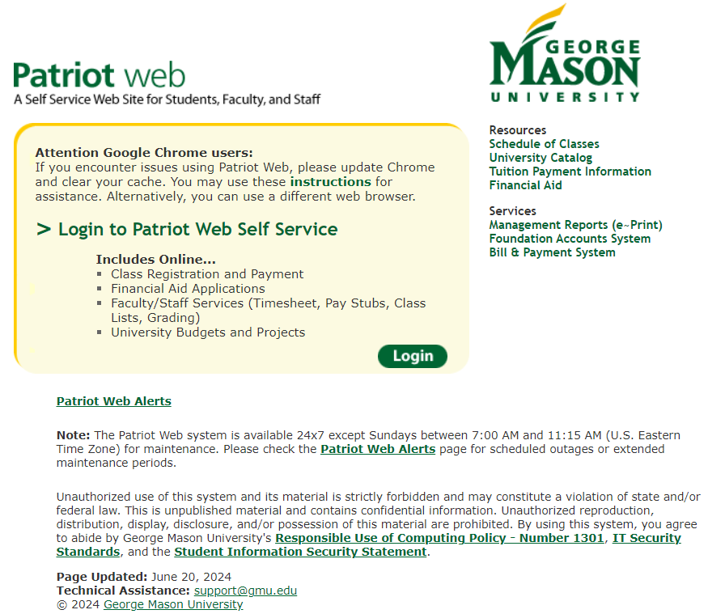

2. Click on Login, either at the top or at the bottom right of the yellow box.

3. Under Mason Username (aka NetID), enter your Username.

4. Under Password, enter your Patriot Pass Password.

5. If you are able to log in, your record is set up and you may proceed to the ID Office for your ID card and to the Parking Office for your parking permit. If you are unable to log in, then your record has not been processed yet. Please wait a day or two and then, if you are still unsuccessful, contact your department.
Since George Mason University requires direct deposit and does not print paper deposit advices, logging onto Patriot Web is the way to check your pay stubs and W2s, and to update your address and emergency contact information. Feel free to access it any time!

Note: To look up your course(s) (dates/times/other details): Tab-Faculty and Advisor Services>Class Schedule>drop down menu to select term and course

